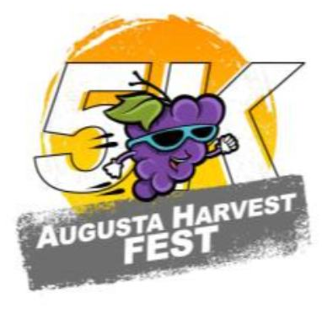

2022 Harvest Fest 5k

September 17, 2022 8am
237 Ferry St, Augusta, MO 63332 (Town Square)

Come run/walk the rolling hills and backdrop of Missouri Wine Country at the Augusta Harvest Fest 5K. What better way to kick off the fall by lacing up the shoes and enjoying the beautiful country along the Missouri River. Harvest Festival activities and events will be happening throughout the weekend and vendors and local businesses around the Augusta Town square will be participating in the weekend festivities. The race will start and finish inside the heart of historic Augusta at Town Square, and feature the beauty of the Katy Trail. All proceeds benefit the Greater Augusta Chamber of Commerce.
Join us for a day of fun!
- 5K Run- Chip timing by Fleet Feet St. Louis – 8am
- Live Music-All day
- Harvest Festival Parade- 10am
- Pumpkin launch
- Timed Drift Bike races
- Pie contest/Pie Walk (town square)
- Bounce house/kids obstacle course- (town square)
- Local and regional Artisans
- FOOD, DRINK and More
- Pony Rides - (town square)
- Shuttle service from dedicated parking points to/from start/finish line (co-located).
Register Here at http://raceroster.com/events/2022/62352/augusta-harvest-fest-5k
$35 entry fee includes race t-shirt

